Assignment – 4

Title: Implement a sample web application scenario using Java Servlets, Java Server Pages and
Java Beans as the server side dynamic content generation technologies. Make use of MVC architecture for implementing the web application.

Problem Statement:
Consider a simple web form where you give a Student Roll number and get back Student Profile details from the database.
- Enter student roll number and marks, get the output of student info on jsp page
- Use servlet as a controller
- Calculate the percentage based on marks
- Make use of MVC architecture, based on Java Servlet, JSP and Java Bean to implement this web based scenario. Make student Bean for calculation and storing info

- Set up Eclipse enterprise with server and required files
  - Window> Preferences> Server> Add
  - Click Add> Apache> tomcat v10 [ Any above version 10]
  - Click Next>Download and Install > Specify the location of extracted directory and the name of server
  - Finish

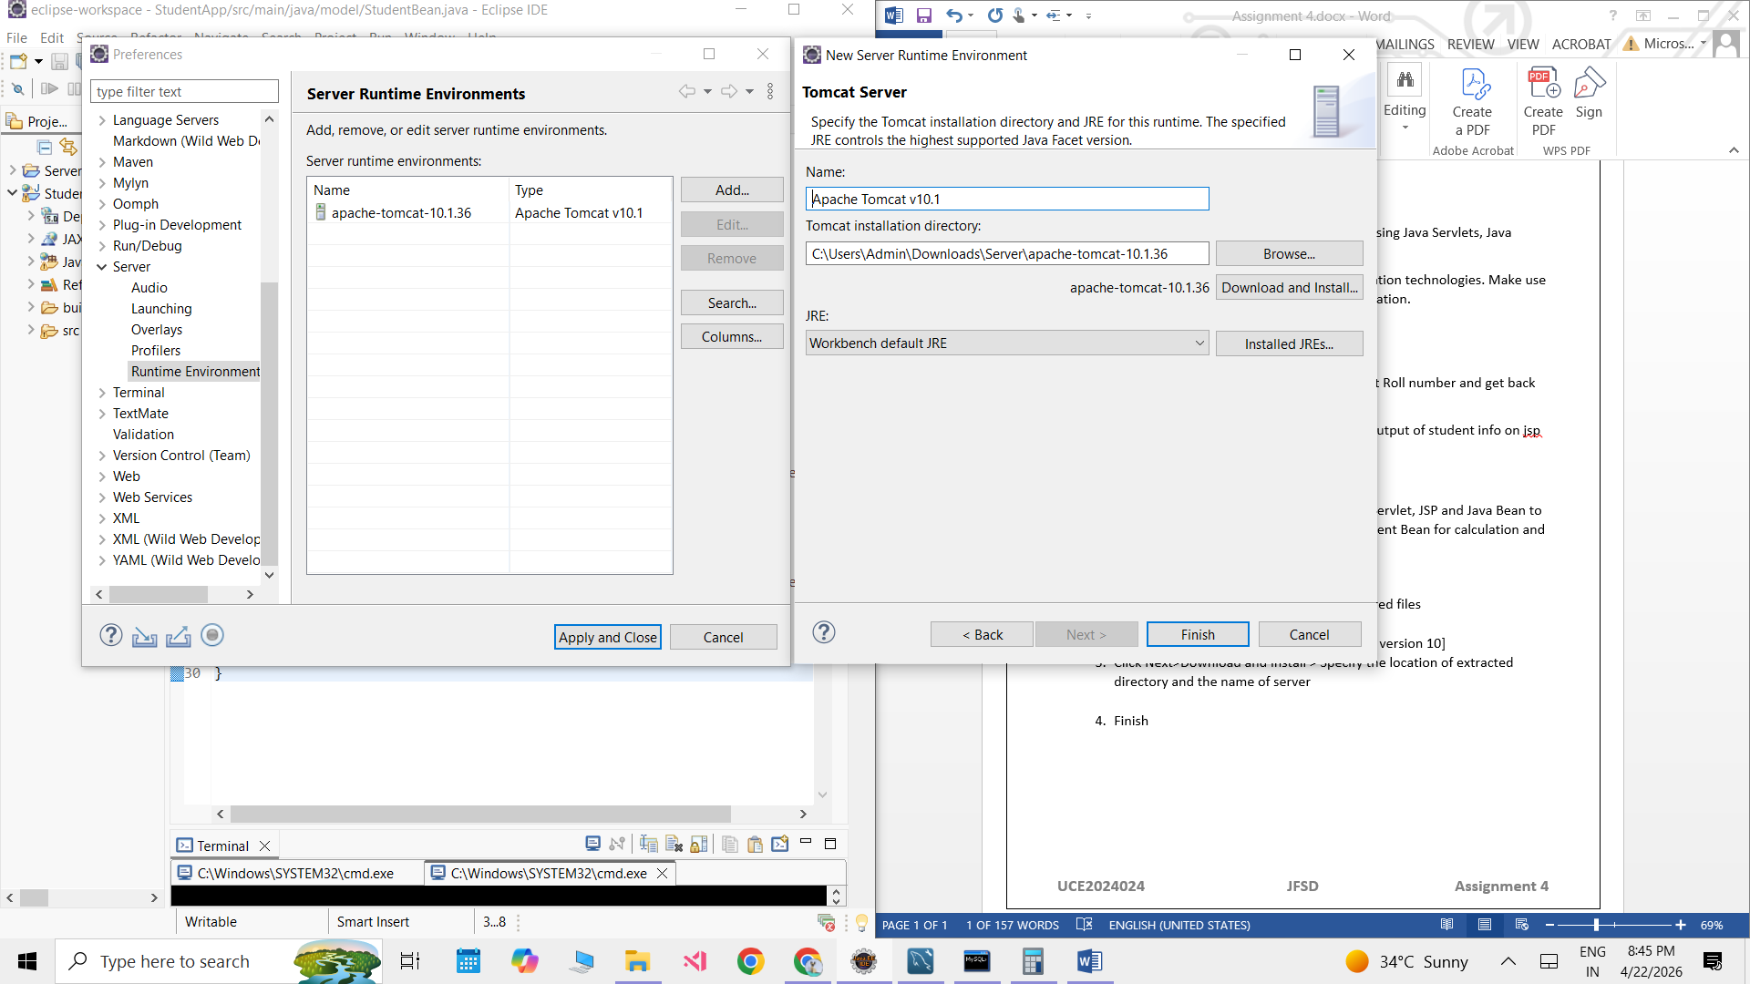

- Set up the project structure
  - Create a dynamic web project
  - Select name and server – If apache tomcats server setup was successful , it will be autoselected, unless you already have another server :)
  - Finish
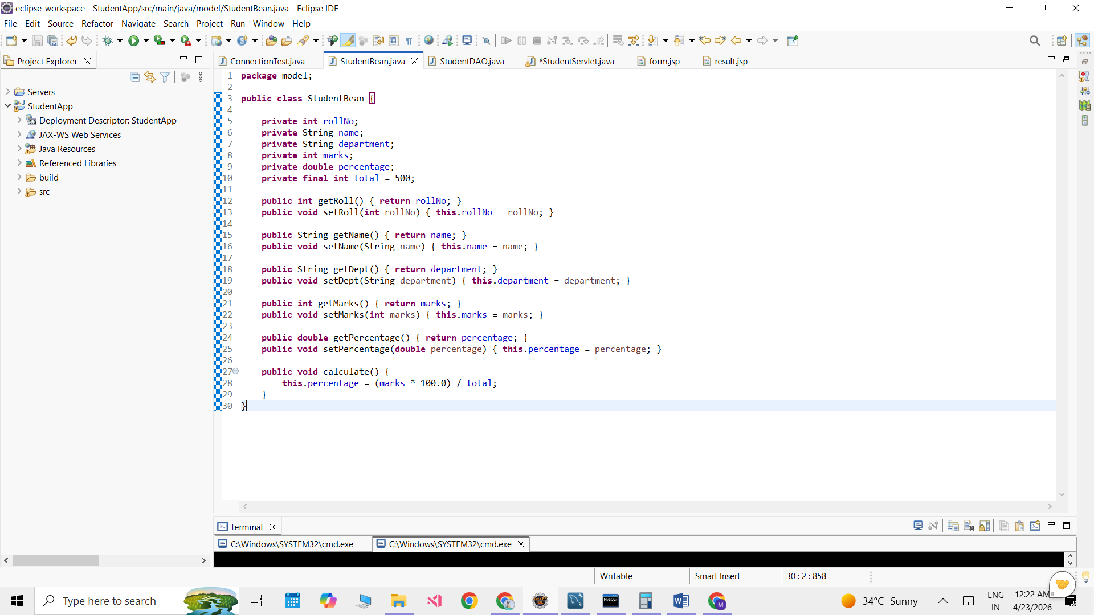

Project Structure
- Set up the database
  - In MySQL client command line:

Mydb.db
mysql> create database student;
Query OK, 1 row affected (0.03 sec)

mysql> use student;
Database changed
mysql> create table student()
-> ;
ERROR 1064 (42000): You have an error in your SQL syntax; check the manual that corresponds to your MySQL server version for the right syntax to use near ')' at line 1
mysql> create table student
-> (roll_no INT Primary Key,
-> name varchar(50),
-> department varchar(50),
-> marks INT,
-> percentage double);
Query OK, 0 rows affected (0.09 sec)
ALTER TABLE student MODIFY percentage DOUBLE DEFAULT 0;
Query OK, 0 rows affected (0.04 sec)
Records: 0 Duplicates: 0 Warnings: 0
insert into student(roll_no,name,department) values (024,"Mansi","Comp");

select * from student;
+---------+-------+------------+-------+------------+
| roll_no | name | department | marks | percentage |
+---------+-------+------------+-------+------------+
| 24 | Mansi | Comp | NULL | NULL |
+---------+-------+------------+-------+------------

  - Set up MySQL connector jars in the eclipse : install the connector and paste jar file in the lib folder

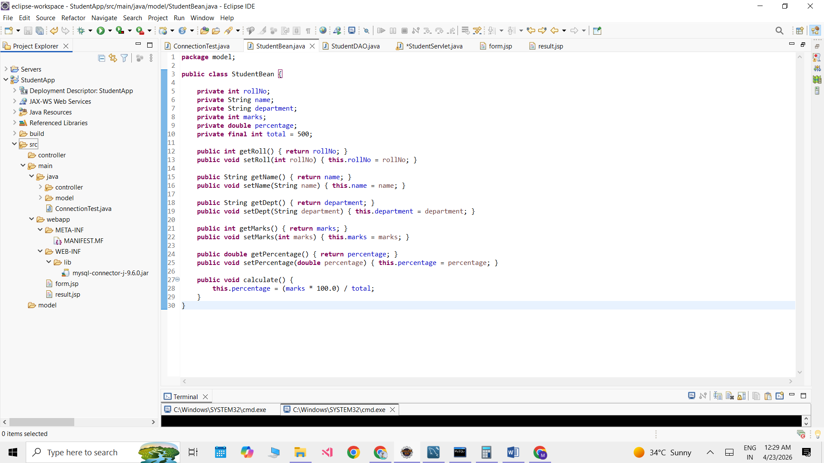

  - Test the connection

ConnectionTest.java
import java.sql.*;
public class ConnectionTest {

public static void main(String[] args) {
try {

Class.forName("com.mysql.cj.jdbc.Driver");
Connection con=DriverManager.getConnection("jdbc:mysql://localhost:3306/student",
"root","mansi");
if(con!=null) {
System.out.println("SUCCESSFULLY CONNECTED");
}

}
catch(Exception e){
System.out.println("Connection Failed");
e.printStackTrace();
}

}

}

Output: SUCCESSFULLY CONNECTED

4. Writing code
1. Create 2 packages – controller and model [Since we want to create it in a MVC architecture]
model>StudentBean.java
package model;

public class StudentBean {

private int rollNo;
private String name;
private String department;
private int marks;
private double percentage;
private final int total = 500;

public int getRoll() { return rollNo; }
public void setRoll(int rollNo) { this.rollNo = rollNo; }

public String getName() { return name; }
public void setName(String name) { this.name = name; }

public String getDept() { return department; }
public void setDept(String department) { this.department = department; }

public int getMarks() { return marks; }
public void setMarks(int marks) { this.marks = marks; }

public double getPercentage() { return percentage; }
public void setPercentage(double percentage) { this.percentage = percentage; }

public void calculate() {
this.percentage = (marks * 100.0) / total;
}
}

model> StudentDAO.java
package model;

import java.sql.*;

public class StudentDAO {

// 🔹 1. FETCH STUDENT DETAILS
public static StudentBean getStudent(int rollNo) {

StudentBean sb = new StudentBean();

try {
Class.forName("com.mysql.cj.jdbc.Driver");

Connection con = DriverManager.getConnection(
"jdbc:mysql://localhost:3306/student",
"root",
"mansi"
);

String query = "SELECT * FROM student WHERE roll_no=?";
PreparedStatement ps = con.prepareStatement(query);

ps.setInt(1, rollNo);

ResultSet rs = ps.executeQuery();

if (rs.next()) {
sb.setRoll(rs.getInt("roll_no"));
sb.setName(rs.getString("name"));
sb.setDept(rs.getString("department"));
sb.setMarks(rs.getInt("marks"));
sb.setPercentage(rs.getDouble("percentage"));
}

con.close();

} catch (Exception e) {
e.printStackTrace();
}

return sb;
}

// 🔹 2. UPDATE MARKS + PERCENTAGE
public static void updateStudent(StudentBean sb) {

try {
Class.forName("com.mysql.cj.jdbc.Driver");

Connection con = DriverManager.getConnection(
"jdbc:mysql://localhost:3306/student",
"root",
"mansi"
);

String query = "UPDATE student SET marks=?, percentage=? WHERE roll_no=?";
PreparedStatement ps = con.prepareStatement(query);

ps.setInt(1, sb.getMarks());
ps.setDouble(2, sb.getPercentage());
ps.setInt(3, sb.getRoll());

ps.executeUpdate();

con.close();

} catch (Exception e) {
e.printStackTrace();
}
}
}

Controller>StudentServlet.java
package controller;

import java.io.IOException;

import jakarta.servlet.RequestDispatcher;
import jakarta.servlet.ServletException;
import jakarta.servlet.annotation.WebServlet;
import jakarta.servlet.http.HttpServlet;
import jakarta.servlet.http.HttpServletRequest;
import jakarta.servlet.http.HttpServletResponse;
import model.StudentBean;
import model.StudentDAO;

/**
* Servlet implementation class StudentServlet
*/
@WebServlet("/StudentServlet")
public class StudentServlet extends HttpServlet {

protected void doPost(HttpServletRequest request, HttpServletResponse response)
throws ServletException, IOException {
request.setCharacterEncoding("UTF-8");
response.setContentType("text/html;charset=UTF-8");
try {
// 🔹 1. Get data from form
int rollNo = Integer.parseInt(request.getParameter("rollNo"));
int marks = Integer.parseInt(request.getParameter("marks"));

// 🔹 2. Fetch student from DB
StudentBean student = StudentDAO.getStudent(rollNo);

// 🔥 3. Check if student exists
if (student.getName() == null) {
response.setContentType("text/html");
response.getWriter().println("<h3>Student not found ❌</h3>");
return;
}

// 🔹 4. Set marks
student.setMarks(marks);

// 🔹 5. Calculate percentage (MODEL logic)
student.calculate();

// 🔹 6. Update DB
StudentDAO.updateStudent(student);

// 🔹 7. Send to JSP
request.setAttribute("student", student);

RequestDispatcher rd = request.getRequestDispatcher("result.jsp");
rd.forward(request, response);

} catch (Exception e) {
e.printStackTrace();
}
}
}

View
Webapp/form.jsp
<%@ page contentType="text/html; charset=UTF-8" pageEncoding="UTF-8"%>
<html>
<head>
<title>Student Form</title>
</head>
<body>

<h2>Enter Student Details</h2>

<form action="StudentServlet" method="post">

Roll No:
<input type="text" name="rollNo" required>
<br><br>

Marks (out of 500):
<input type="number" name="marks" min="0" max="500" required>
<br><br>

<input type="submit" value="Submit">

</form>

</body>
</html>

Webapp/result.jsp
<%@ page contentType="text/html; charset=UTF-8" pageEncoding="UTF-8"%>
<%@ page import="model.StudentBean" %>

<%
StudentBean s = (StudentBean) request.getAttribute("student");
%>

<html>
<head>
<title>Student Result</title>
</head>
<body>

<h2>Student Profile</h2>

<% if (s != null) { %>

Roll No: <%= s.getRoll() %> <br><br>
Name: <%= s.getName() %> <br><br>
Department: <%= s.getDept() %> <br><br>
Marks: <%= s.getMarks() %> <br><br>
Percentage: <%= s.getPercentage() %> % <br><br>

<% } else

{ %>

<h3>No data found ❌</h3>

<% } %>

</body>
</html>

5. Execution
1. Start the apache server
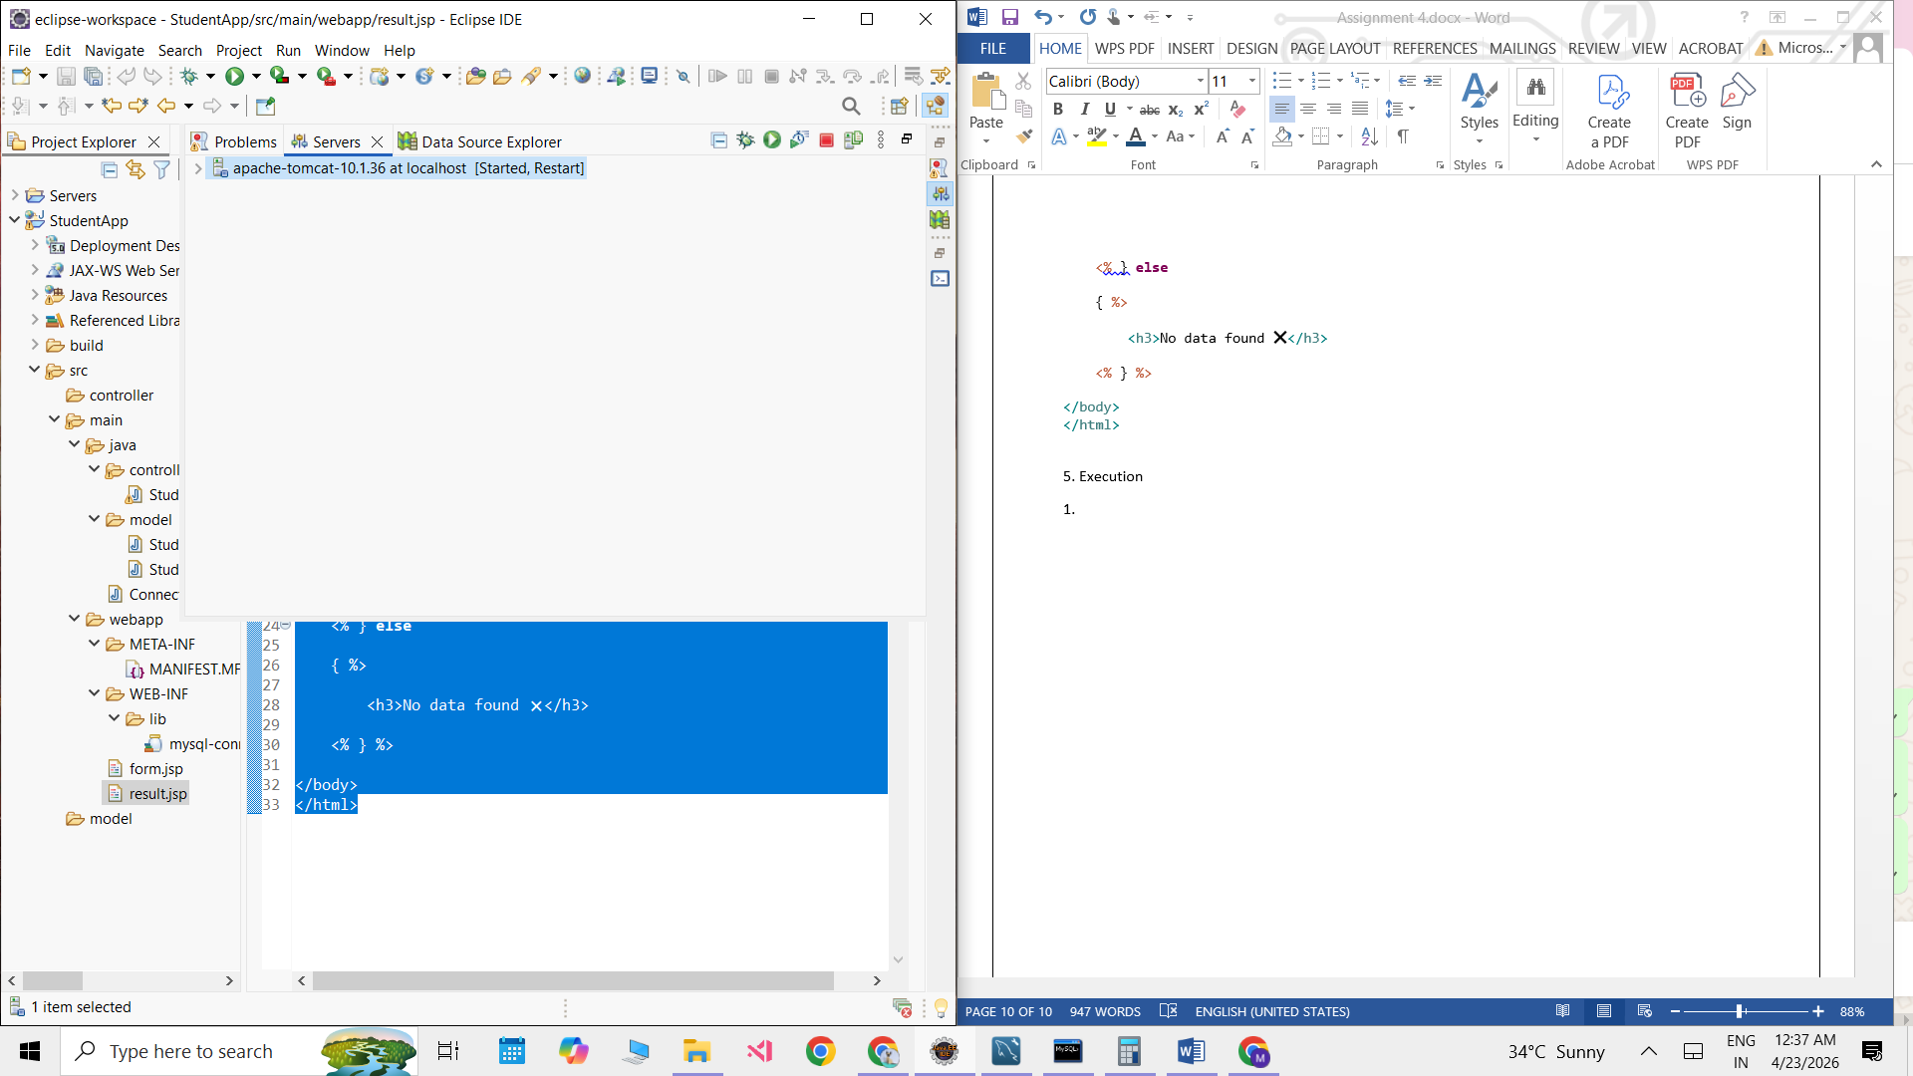
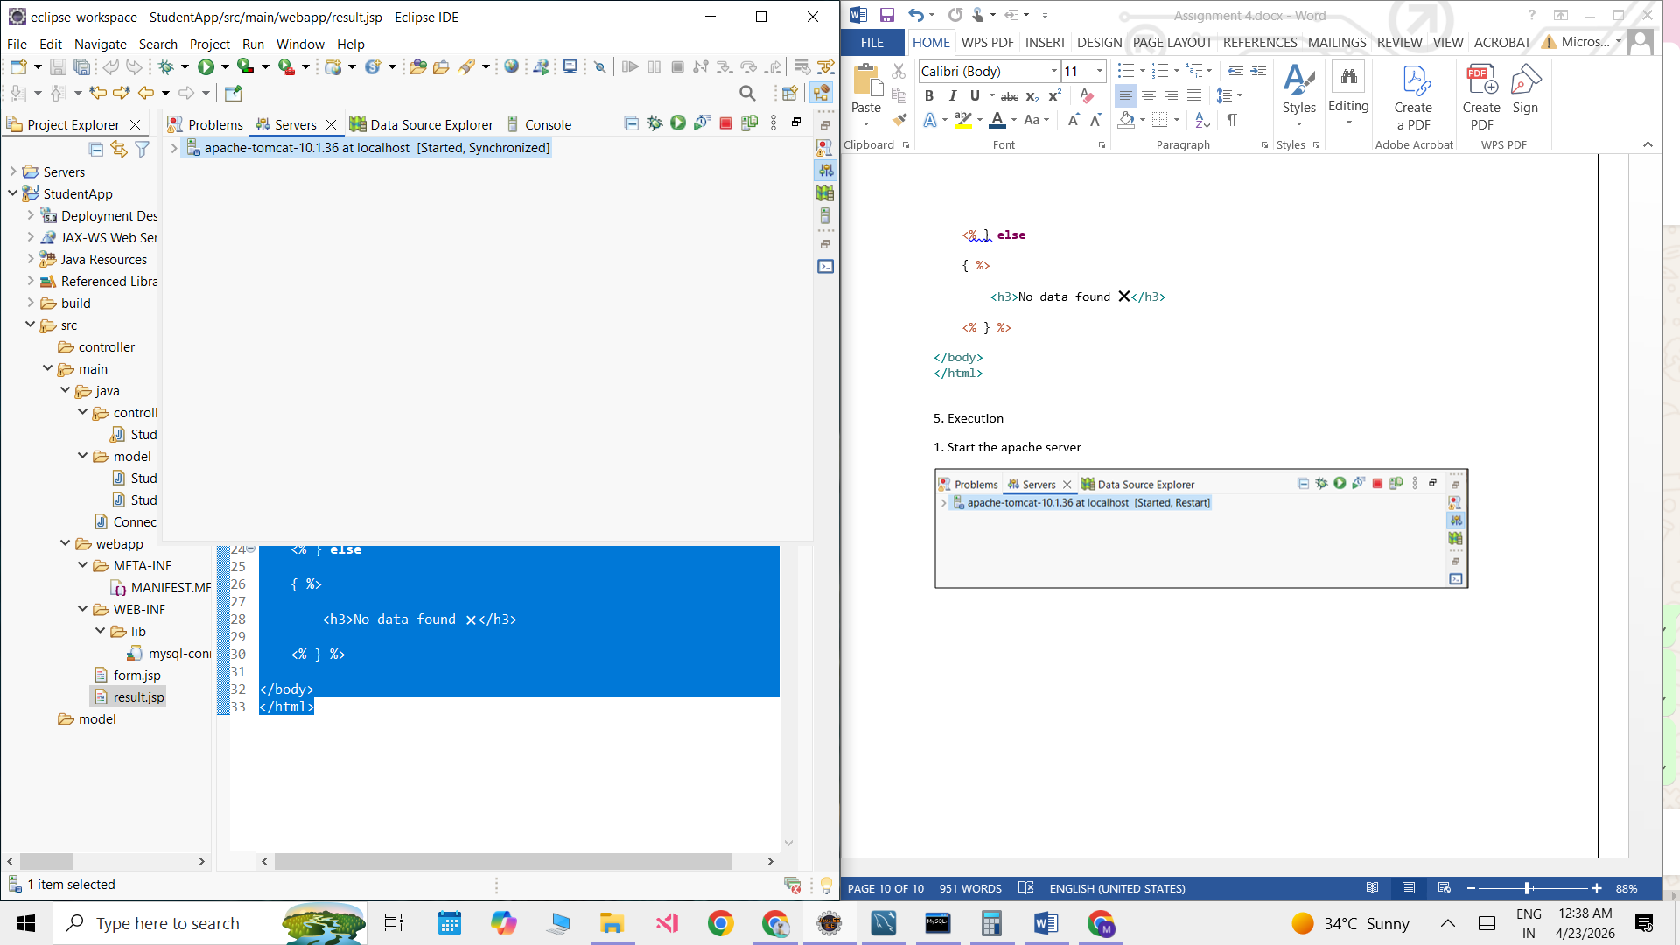

2. Since apache tomcat runs on 8080 port , if any other proves is running on the port , our program wouldn’t run
So if error like – 8080 already in use appears, we use:
- C:\Users\Admin\eclipse-workspace\StudentApp\src\main\java>netstat -ano | findstr : 8080
TCP 0.0.0.0:8080 0.0.0.0:0 LISTENING 29064
TCP [::]:8080 [::]:0 LISTENING 29064
- taskkill /PID 29064 /F
This would kill the existing process , then we can run apache tomcat once more
- if no issues , visit
http://localhost:8080/StudentApp/form.jsp
http://localhost:8080/StudentApp/StudentServlet

